Benefits of Membership

Members are empowered with new knowledge and professional development targeted towards reaching their full potential.

Membership benefits include:
- Chapter Meetings
- Personal and Professional Growth Opportunities
- Leadership Development
- State and International Scholarships for members
- Grants for college students
- International Speakers Fund
- Research
- Legislative Updates and Forums
- Mentoring and Fellowship
- Networking Opportunities
- State and International Conferences, workshops, seminars
- Travel and Study
- Professional Journal
- Newsletters and other publications for members
- Insurance offerings and group discounts
- Mini Grants

DKG members are women educators from 17 countries impacting education worldwide.

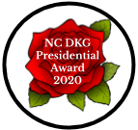
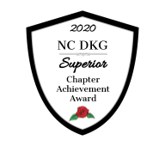
To unite women educators of the world in a genuine spiritual fellowship.
Purposes of DKG International
NC DKG
North Carolina State Organization
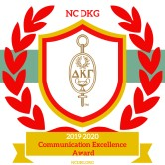
To honor women who have given or who evidence a potential for distinctive service in any field of education.
GAMMA DELTA CHAPTER
The Delta Kappa Gamma Society International
To advance the professional interest and position of women in education. To initiate, endorse and support desirable legislation or other suitable endeavors in the interests of education and of women educators. To endow scholarships to aid outstanding women educators in pursuing graduate study and to grant fellowships to non-member women educators.
To stimulate the personal and professional growth of members and to encourage their participation in appropriate programs of action.
To inform the members of current economic, social, political and educational issues so that they may participate effectively in a world society.

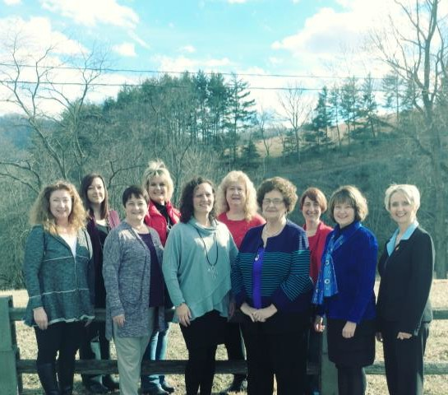
Gamma Delta’s NBCT’s Janie Cook, Sherrie Hines, Beth Phillips, Missey Weaver, Dana Henson, Susie Miller, Polly Jones, Mandy Taylor, Elaine Cox, and Carmen Wilson
Not Pictured: Laura Bowers, Jane Calhoun, Kim Choate, Patti Cox, Terry Edwards, Dianne Eldreth, Sandra Peterson, & Judy Tedford

GAMMA DELTA CHAPTER 2020-2022 OFFICERS

Christina Pennington/Sherrie Hines-Co-Presidents
Diane Eldreth/Leslie Clark-Co-Vice Presidents
Barbara Lyon-Recording Secretary
Dana Henson-Corresponding Secretary
Ina Jean Barnes-Treasurer
Mandy Taylor-Parliamentarian
WEBSITE:
https://ncgammadelta.dkg.weebly.com
FACEBOOK:
facebook.com/GammaDeltaChapter
NC DKG President, Dr. Teresa Cowan
For Key Women Educators
Delta Kappa Gamma promotes professional and personal growth of women educators and excellence in education.

Gamma Delta Chapter serves women in Alleghany and Ashe Counties of North Carolina. The Chapter was chartered in 1976 and serves active and retired women in many fields of education.
Membership is by invitation only and is considered a prestigious honor.
 | Gamma Delta supports | Gamma Delta’s NBCT’s Janie Cook, Sherrie Hines, Beth Phillips, Missey Weaver, Dana Henson, Susie Miller, Polly Jones, Mandy Taylor, Elaine Cox, Carmen Wilson  Not Pictured: Laura Bowers, Jane Calhoun, Kim Choate, Patti Cox, Terry Edwards, Diane Eldreth, Sandra Peterson, and Judy Tedford
 | and encourages
 | educators to earn
 | National Board
 | Certification. We also
 | support advanced
 | degrees (MA and
 | Doctorate)
Celebrating 45 years
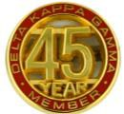
Leading women educators impacting education worldwide.
GRANT-IN-AID |  |  |  | IMAGINATION ASHE AND ALLEGHANY  Dolly Parton's Imagination Library is a book gifting program that mails free books to children from birth until their fifth birthday with a goal to increase literacy. Both Imagination Alleghany and Imagination Ashe are affiliates of Dolly Parton’s Imagination Library. Through this program we benefit the preschool children of Alleghany and Ashe Counties, North Carolina. Gamma Delta members raise and donate funds to support these programs.  WORLD FELLOWSHIP  Gamma Delta members donate to the Delta Kappa Gamma World Fellowship Fund supporting the advancement of teaching worldwide one learner at a time.  MINI GRANTS  Gamma Delta awards mini grant(s) in support of educators that will benefit students and may not otherwise be covered by school budgets.  COMMUNITY SUPPORT
Gamma Delta provides a Grant-In-Aid to promote non-certified educational endeavors. Annual awards of $500 are made to deserving candidates pursuing careers in education.
SUPPORT OF NEW/BEGINNING TEACHERS
Gamma Delta supports first-year teachers and teachers who are beginning their careers in Alleghany and Ashe Counties. Members donate school supplies and treats throughout the school year. Members mentor new/beginning teachers and volunteer in classrooms. These teachers are recognized during National Educators’ Week.
BOOKS FOR BACKPACKS
Books for Backpacks are collected annually by Gamma Delta members and placed in backpacks weekly during the summer vacation months for students who are in need.
SCHOOLS FOR AFRICA
Gamma Delta participates with UNICEF to provide money for teacher education in several African countries.

